

CREATING A SERVICE
DevOps Certification Training

support@intellipaat.com
+91-7022374614
US: 1-800-216-8930(Toll Free)

CREATING A SERVICE
Steps for Master

Step 1: We will create a nodeport service for our nginx deployment, run the following command:
kubectl create service nodeport nginx –tcp=80:80

Step 2: Note down the Nodeport for this service by running the command,
kubectl get svc nginx

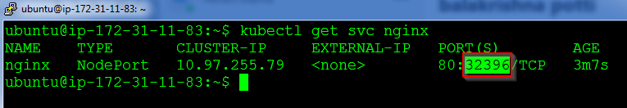

Step 3: Verify the working of the service by browsing to the IP address of the master or slave with this port
